|  |  |  |  |
| --- | --- | --- | --- |
| 1 | | 507,852.5714285714 | |
| NUMERO DE FRONTERAS | | ENERGIA AGREGADA | |
|  | | | |
| NO | | 0 | |
| CONTRATO | | VENCIMIENTO CONTRATO | |
|  | | | |
| 123,996,003 | 26 | | 4,992,000 |
| INGRESO 2020 | DÍAS CERTIFICADOS 2020 | | ENERGIA RESPALDADA 2020 |
|  | | | |
| 1,913,909,718 | 173 | | 82,309,114 |
| INGRESO 2021 | DÍAS CERTIFICADOS 2021 | | ENERGIA RESPALDADA 2021 |

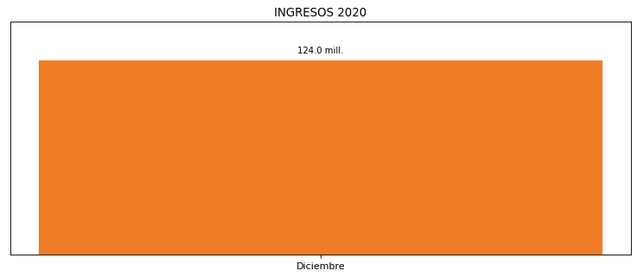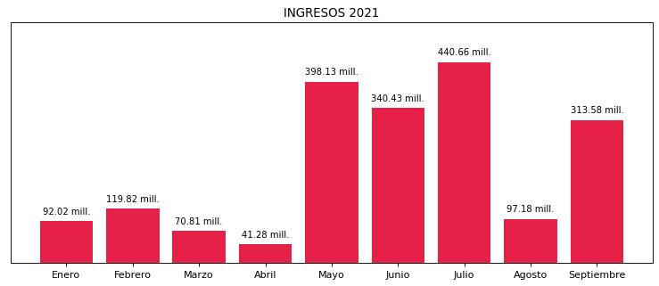

|  |
| --- |
| **FRONTERA ENERGY**  USUARIO |

|  |
| --- |
| **Mateo Porras**  Ejecutivo de cuenta |

|  |
| --- |
| **0**  Primera fecha: PUNTO FOCAL |

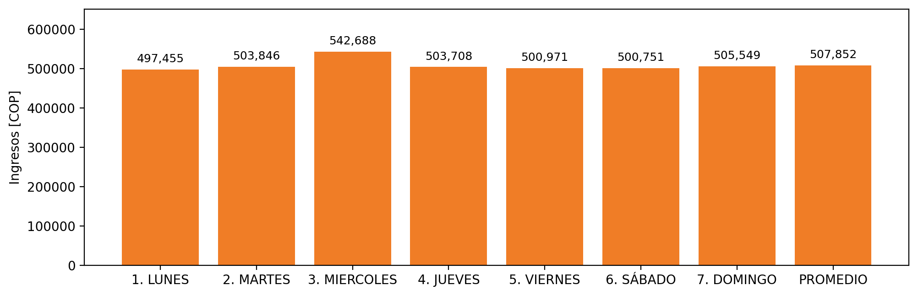

|  |  |  |  |  |  |  |  |  |  |
| --- | --- | --- | --- | --- | --- | --- | --- | --- | --- |
| **FRONTERA COMERCIAL** | **TIPO DDV** | **COD SIC** | **PREDIO** | **PROMEDIO** | **MARGEN** | **ÚLTIMA DESCONEXION** | **DÍAS CERTIFICADOS** | **ACTUALIZACION** | **PROXIMA PRUEBA DDV** |
| Quifa III - Quifa IV | Frt37374 | Frt24197 | Prd01936 | 507,852 | 4,31 | 2021-08-11 | 29.0 | 2021-11-19 | 2021-12-27 |